**INTERREG IMPROVEMENT**

**Tecnical and Steering Committee**

**18th November 2021**

**Tecnical Committee**

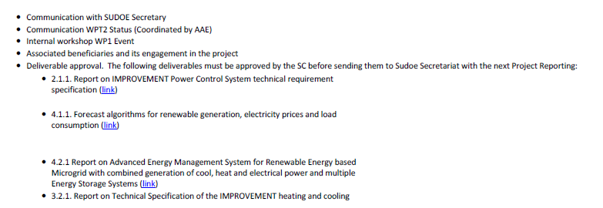

**Steering Committee**

